**Question 01:**

**3.1 Performance measures**

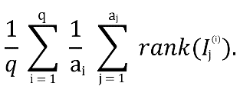Let {Q1,...,Qq} be the set of query images. For the i-th query Qb let I1(i),...,Ij(i) in the result. We use three performance measures [7]:

1. Avg-r =

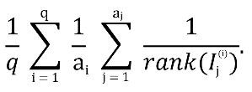

1. Avg-p =
2. Recall vs. Scope. For query Qi and scope S(S>0):

recall r = | {Ij(i) | rank (Ij(i)) ≤ S} | / ai.

**Question 02:**

**Physical:** Saena primarily faces the physical challenges; as a traveling merchant’s daughter, she has learned to fight; she faces the Dark Fae but suffers weakness in her mental defenses against their magic; Aerim learns to fight Saena and helps her learn from Seana and help to defend herself mentally.

**Magical:** Aerim is surprisingly resilient to magic and discovers his growing powers as he and Saena venture into the Forest to investigate their foe and find the root to the decay of the land; he must ultimately confront the truth that his mother was a Dark Fae and was responsible for introducing a sickness to the human race.

**Question 04:**

|  |  |  |  |  |  |  |
| --- | --- | --- | --- | --- | --- | --- |
| **Region** | **District** | **Store**  **Name** | **Employee**  **Name** | **Customer**  **Count** | **Cost** | **Sale** |
| **± Ali** | **Total** |  |  | **153** | **9724** | **13149** |
|  | **± Ahmed** | **Total** |  | **153** | **9724** | **13149** |
|  | **± Imtiaz** |  |  |  |  |
|  | **Ayaz** | **53** | **611** | **830** |
| **Wajahat** | **40** | **731** | **1249** |
| **Maaz** | **60** | **8382** | **10890** |
| **Total** |  |  |  | **153** | **9724** | **13149** |

**Question 05:**

**Computer science, the study of computers and computing, including their theoretical and algorithmic foundations, hardware and software, and their uses for processing information. The discipline of computer science includes the study of algorithms and data structures, computer and network design, modeling data and information processes, and artificial intelligence. Computer science draws some of its foundations from mathematics and engineering and therefore incorporates techniques from areas such as queueing theory, probability and statistics, and electronic circuit design. Computer science also makes heavy use of hypothesis testing and experimentation during the conceptualization, design, measurement, and refinement of new algorithms, information structures, and computer architectures.**

*Computer science is considered as part of a family of five separate yet interrelated disciplines: computer engineering, computer science, information systems, information technology, and software engineering. This family has come to be known collectively as the discipline of computing. These five disciplines are interrelated in the sense that computing is their object of study, but they are separate since each has its own research perspective and curricular focus. (Since 1991 the Association for Computing Machinery [ACM], the IEEE Computer Society [IEEE-CS], and the Association for Information Systems [AIS] have collaborated to develop and update the taxonomy of these five interrelated disciplines and the guidelines that educational institutions worldwide use for their undergraduate, graduate, and research programs.)*

The major subfields of computer science include the traditional study of computer architecture, programming languages, and software development. However, they also include computational science (the use of algorithmic techniques for modeling scientific data), graphics and visualization, human-computer interaction, databases and information systems, networks, and the social and professional issues that are unique to the practice of computer science. As may be evident, some of these subfields overlap in their activities with other modern fields, such as bioinformatics and computational chemistry. These overlaps are the consequence of a tendency among computer scientists to recognize and act upon their field’s many interdisciplinary connections.

**Question 06:**

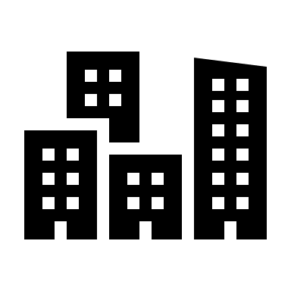San Francisco is the financial, cultural, and transportation center of the San Francisco Bay area, a region of 7.15 million people includes San Jose and Oakland. The only consolidated city-country in California, is encompasses a land area of about 121 km2 on the northern end of the San Francisco Peninsula, giving it a density of about 6,632 people per km2. It is the most densely settled large city (population greater than 200,00) in the state of California and the second-most densely populated large city in the United States after New York City. Today, San Francisco is one of the top tourist destinations in the world, ranking 33rd out of 100 most visited cities worldwide, and is renowned for its chilly summer fog, steep rolling hills, eclectic mix of architecture, and its famous landmarks, including the **Golden Gate Bridge**, cable cars, and Chinatown. The city is also a principal banking and finance center, and the home to more than 30 international financial institutions, helping to make San Francisco rank eighteenth in the world’s top producing cities, ninth in the United States, and thirteenth place in the top twenty global financial centers.